PAINTBOX SOCIAL  NEWSLETTER | 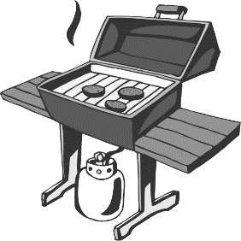  PaintBox Pot Luck BBQ Dinner to honour the people who work for us in the building: the cleaning crew, the super, the building manager. Join us Sunday Sept 7 at the BBQ on the 4th floor. 6 – 9:30PM (Rain date: Sun. Sept 14) The Social Committee to provide burgers and hotdogs.  This is a free activity. BYO beverages (no beer or alcohol).  People in ODD NUMBER suites, please bring a side dish to share. People in EVEN NUMBER suites, please bring a dessert to share.  So that we can order the right amount of food, please RSVP to paintboxsocial@gmail.com. Be sure to tell us how many from your suite will be attending.  PaintBox Night at the Movies – in the theatre on the 2nd floor. Free! Tuesday September 9 at 8:00 sharp.  Dead Poets Society (1989)  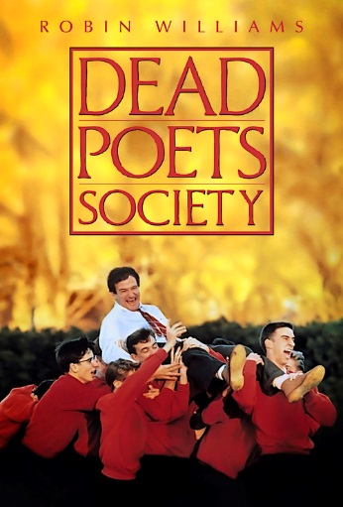  Robin Williams, Robert Sean Leonard, Ethan Hawke  English teacher John Keating inspires his students to a love of poetry and to seize the day.  RSVP by stopping by the concierge desk in the lobby or emailing them at paintbox.concierge@gmail.com . There are only 17 seats, so reserve yours today!  We have an active Social Committee. Please join our committee and be active in the PB community!

